TT Motorsports WIY Trailing Arm Instructions
For 49inch, 55inch and 60Inch Links.
These WIY trailing arms are designed to fit together with relative ease. Clamps, grinders, hammers, spacers, bolts, common sense, and Fabrication talent will be required to assemble.
NOTE: 49inch links are used in the instructions So pieces may look slightly different on other sizes. Assembly is the same process for all sizes. 55inch links require additional cutting. See 55Inch Link CUT Instructions at end.
Before starting on the kit I lay out all the pieces to make sure you have left and right hand sides of each. Second step I do is cut out the shock bolt pocket tubes as well as drain tubes and have them ready for the time to install those. Attached at the end of these instructions are the Cut dimensions and angles for those tubes. Bushing assembly weld on tube needs to be atleast 3” wide to be able to weld to end of trailing arm. Neither are provided in the kit.
Step 1: Grab the 2 Main Ribs. The (2) Angle Shock Doubler Plates and the Shock Pocket Bottom Plate. Using 1.5” spacers and bolts assemble them as shown in the photo. NOTE: The spacers I use are .020 oversized to assure shock fitment after welding. I recommend doing the same with shock spacers or stacking washers, etc to get correct spacing.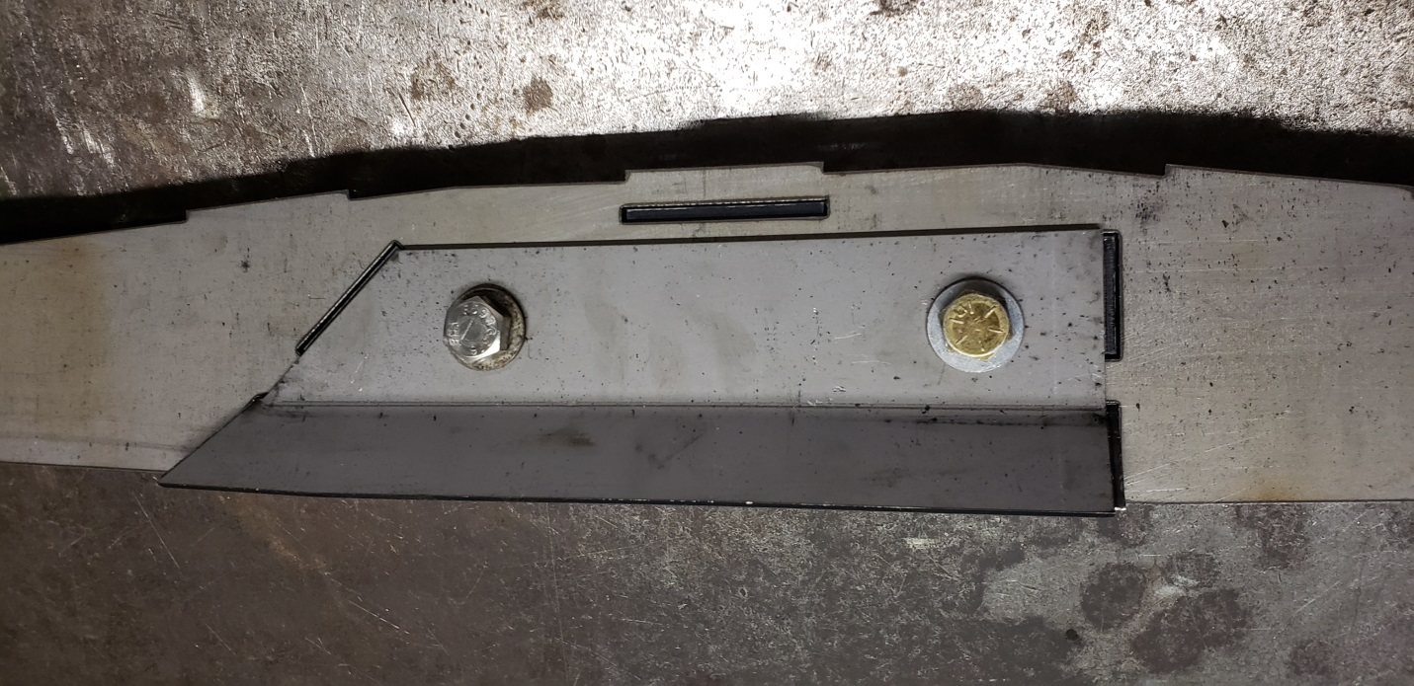
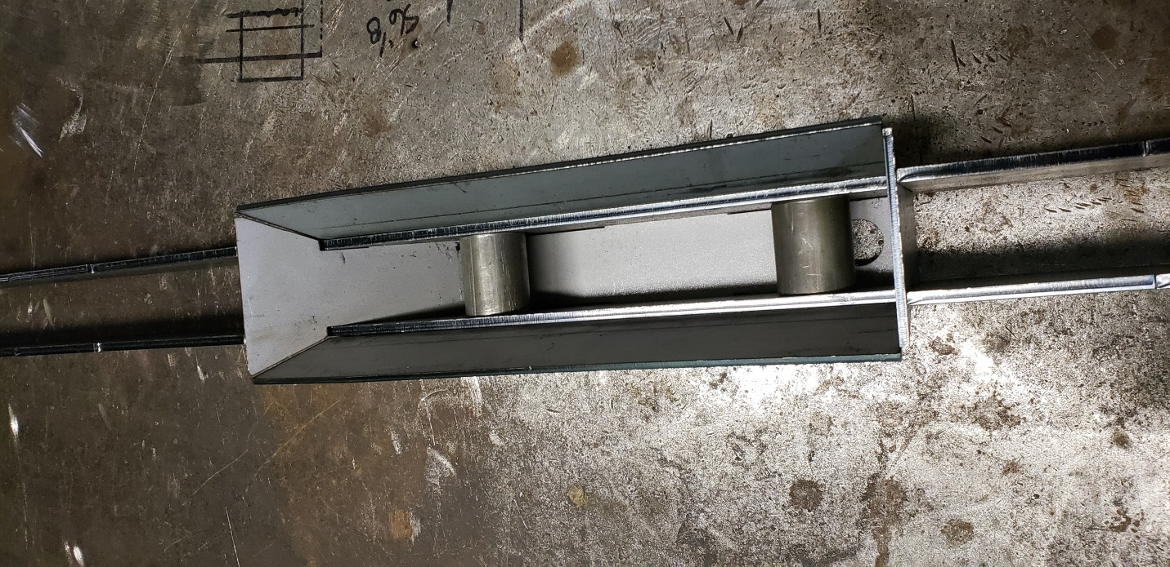
Step 2: Tack the shock pocket together.
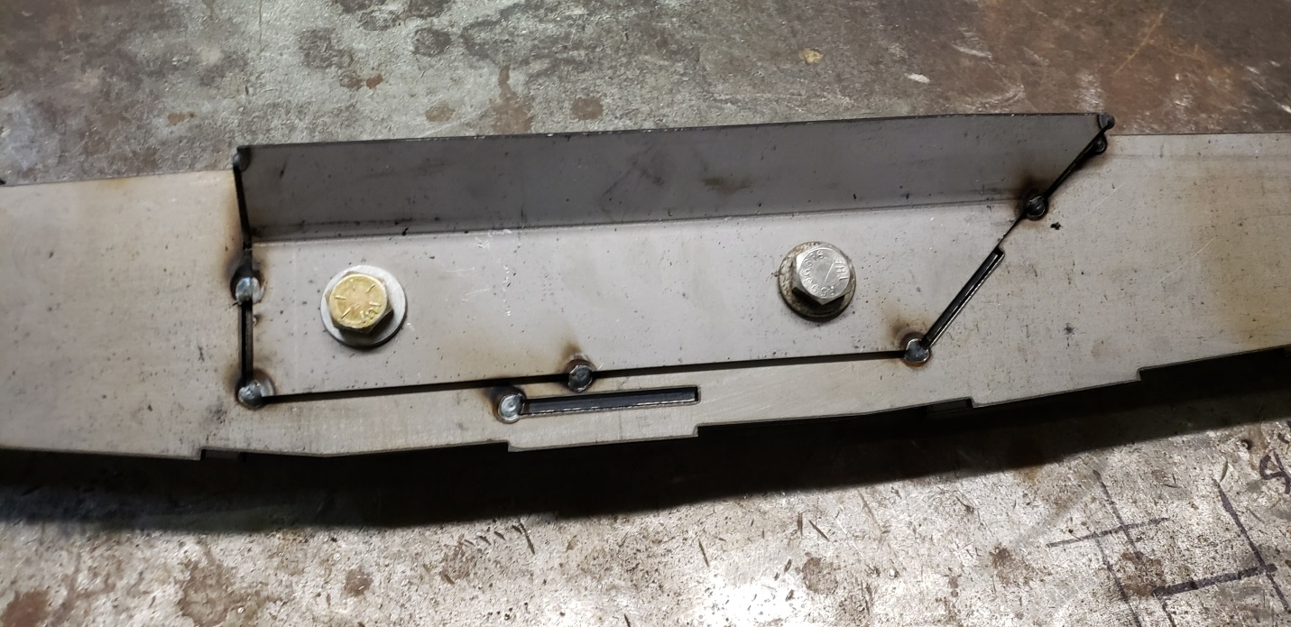
Step 3: Before welding the shock pocket tack the square bung into place. Make sure the top of the bung is flat with top of the link, as well as the bung is pushed tight against the end of the link. Clamp to hold in place while you make sure it’s flush and square.
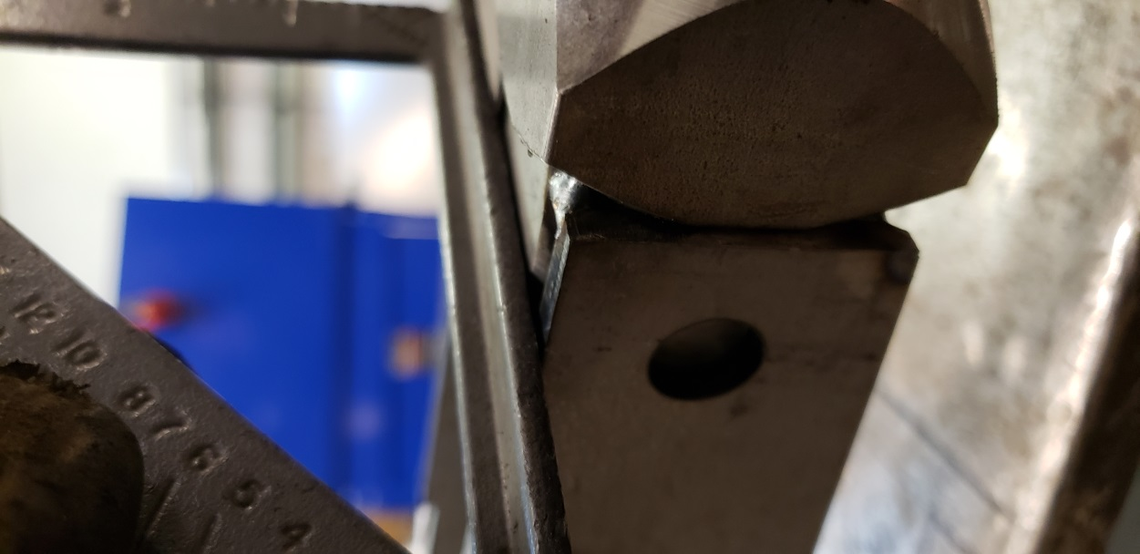
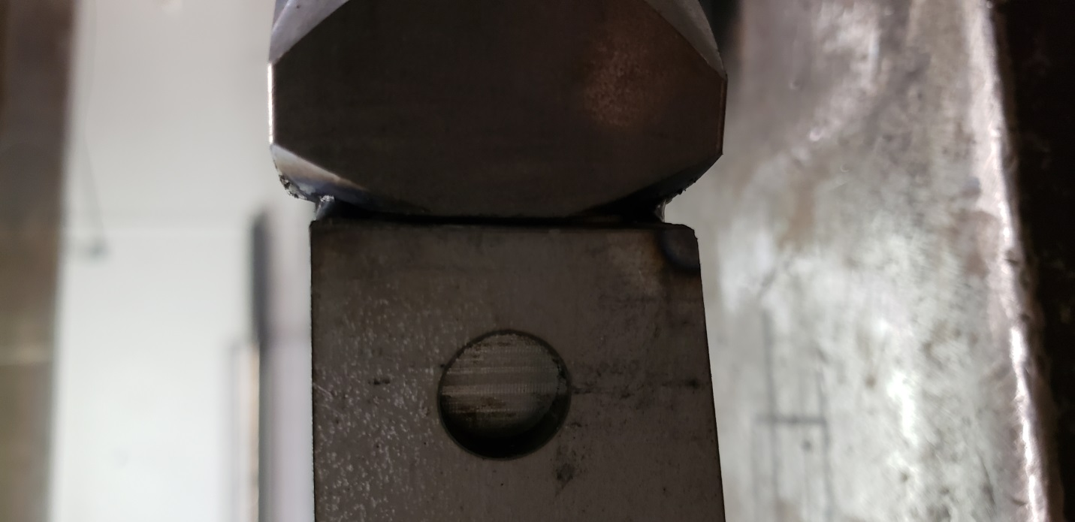
Step 4: Weld the Bung and shock pocket together. On the bung I weld the tops and bottom of the bung to the side plates as well as a good weld in the plug hole. The Shock Pocket weld the outside of it fully on both sides as well as the tab n slot hole. Also weld the bottom fully and weld between the main ribs to top as well.
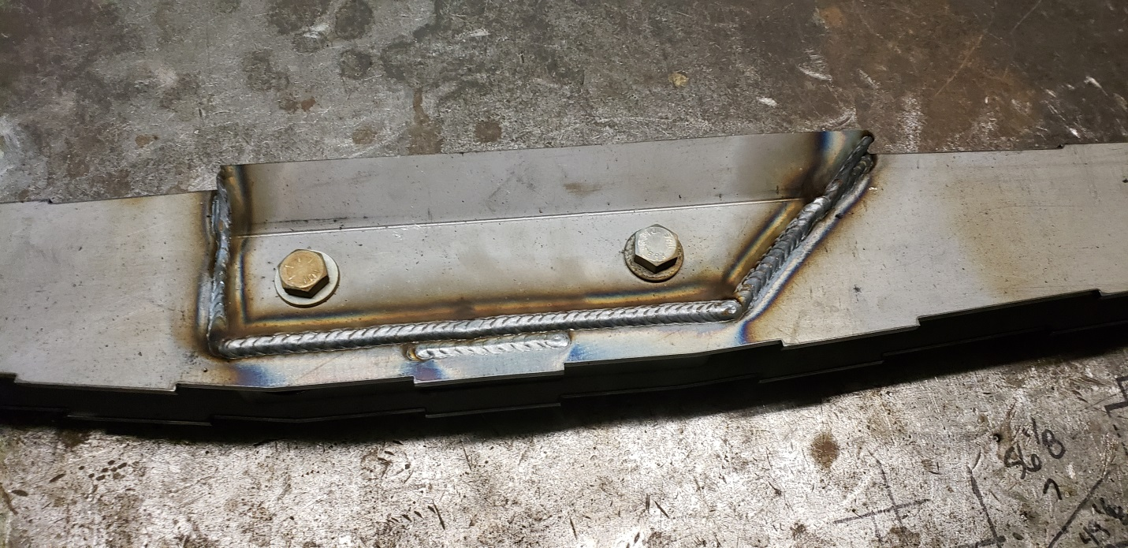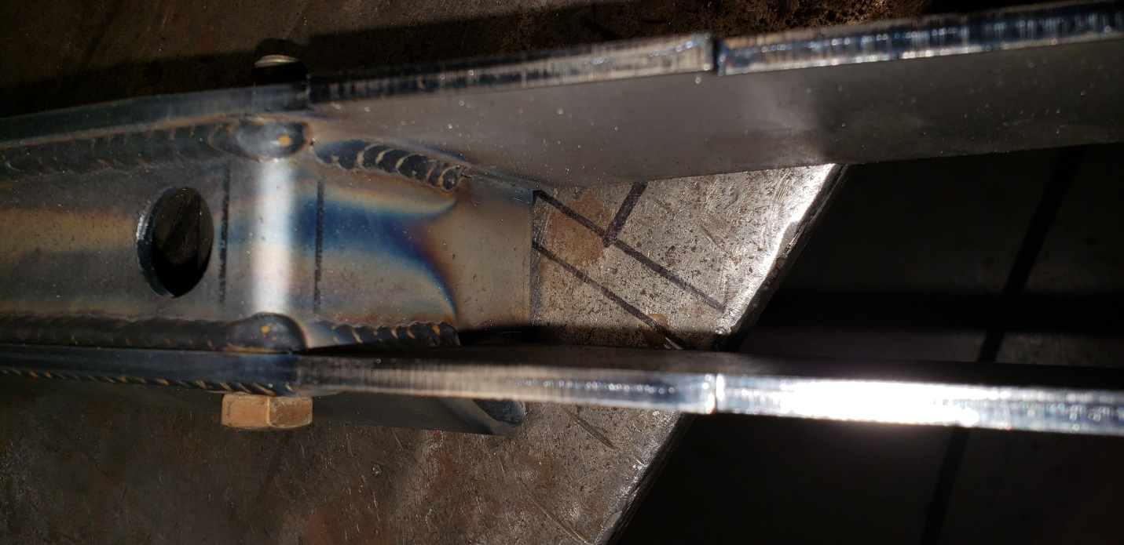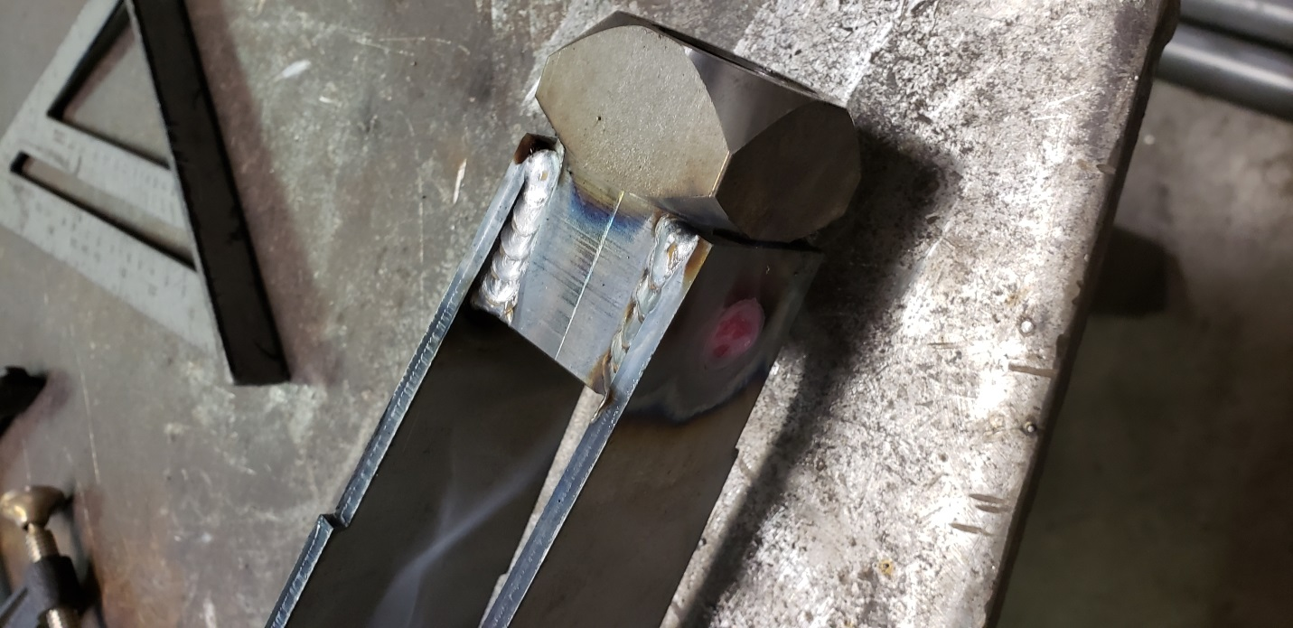
Step 5: Gather all the outer plates, Left and Right. Grind the welds on top of the bung flush with top of side plates on links. Note: 49inch links in photo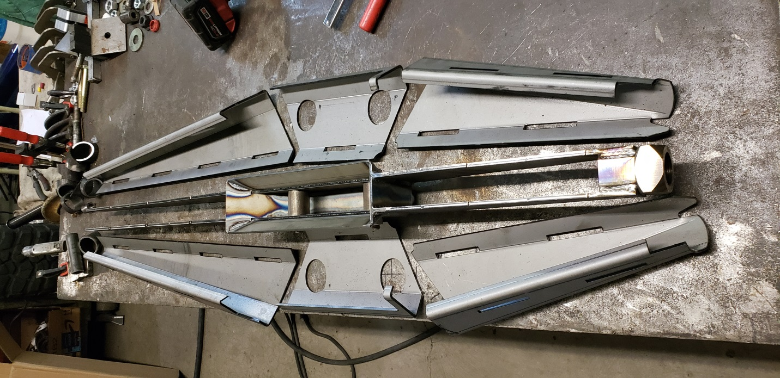
Step 6: Assemble the Front and Back side plates. The plates will fit tight, start by fitting the top tab n slots into the piece and then swinging bottoms together. The Bottoms will have a gap so a c-clamp is required to pull them together. Clamp them tight until there is minimal or no gap along bottom edge. Tack them in a few spots on top and bottom. I avoid tacking in plug weld holes in case I need to take apart, it’s hard to grind in those. The rear side plates on 60inch links will require some minor grinding to fit around the main ribs and bung. That is normal so grind main rib until it fits.
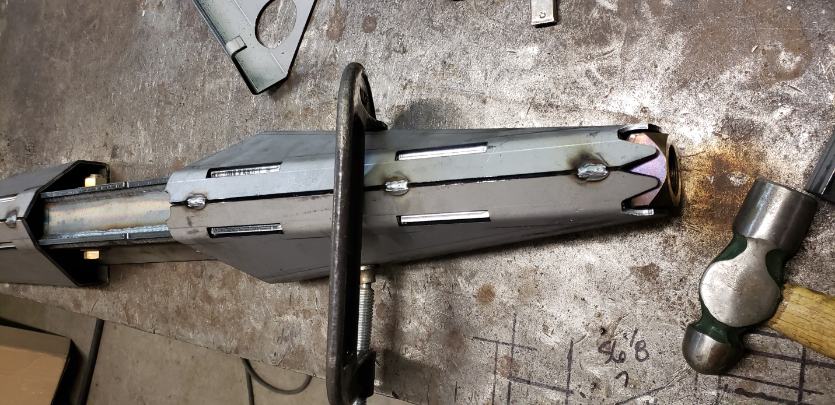
Step 7: The plates are designed with a small gap from bung to ease in assembly. Once plates are tacked on a few well placed hits with the hammer closes the gap for perfect fitment.
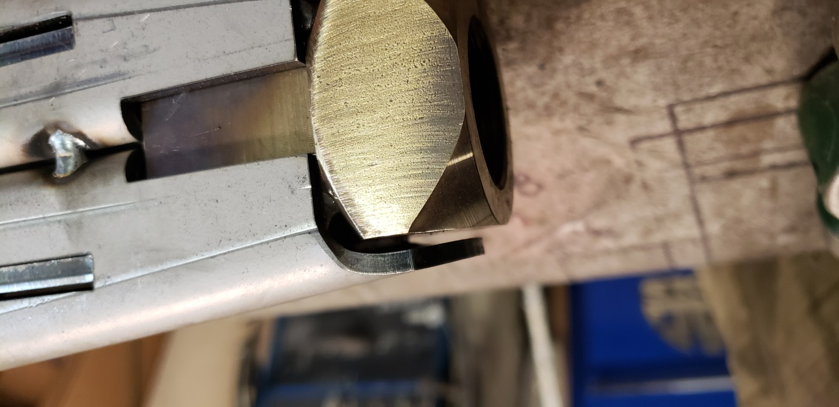
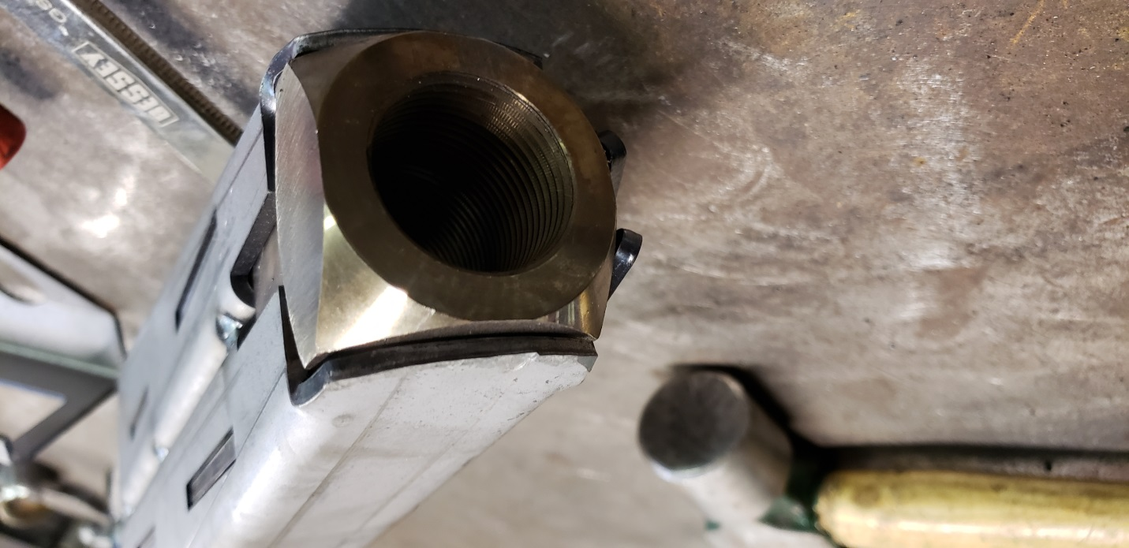
Step 8: Grab the Cut Shock tubes and make sure they are deburred inside and out. Now fit them onto the side plates centering them around the shock bolt and orientating them so the angle matches the side plates of the links. To center the tubes I used a ¾” socket wrapped with tape to fit into a piece of 1.5” x .120 DOM tube that fits inside the 1.75x.120 DOM tube used for shock bolt tubes.
DO NOT WELD THEM YET>>>>>>>
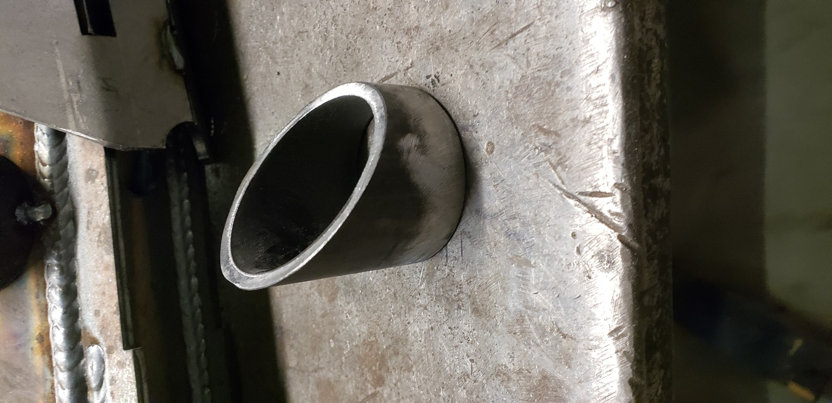
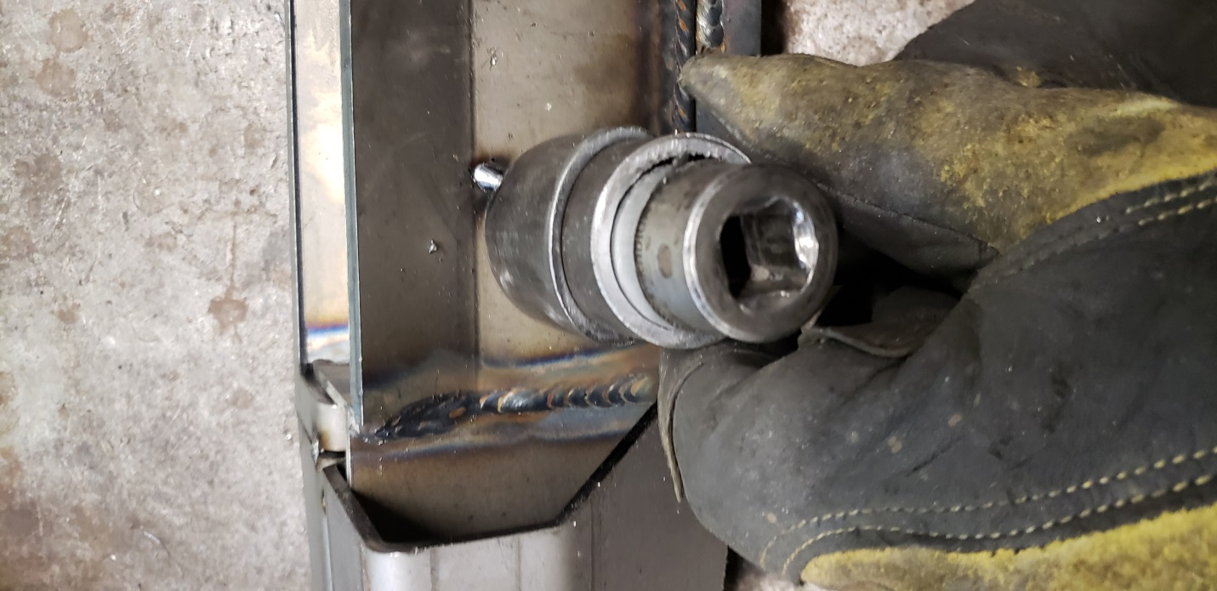
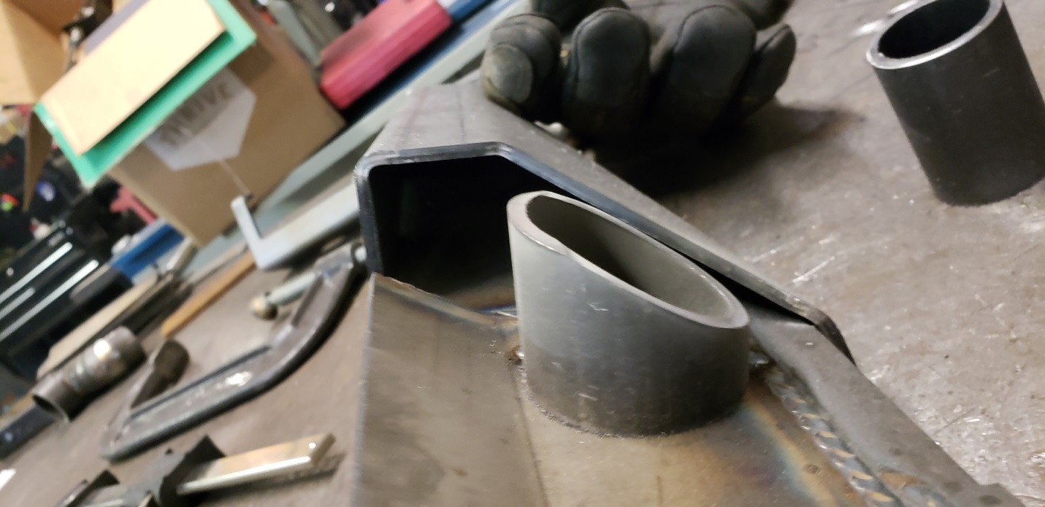
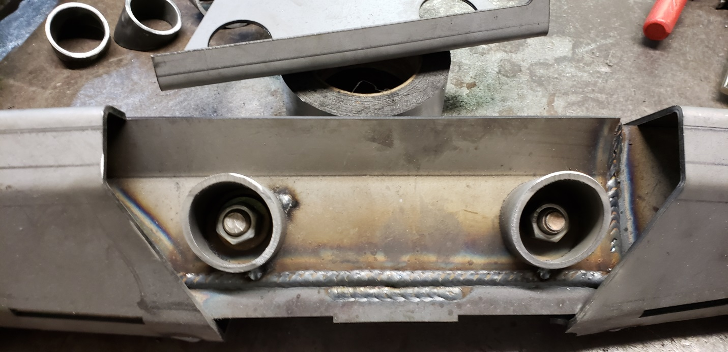
Step 9: After tacking them in place. DO NOT WELD YET. Test fit the side plates and grind the shock tubes if necessary to get the side plates to fit flush with the front and rear side plates as well as the top and bottoms of the links.
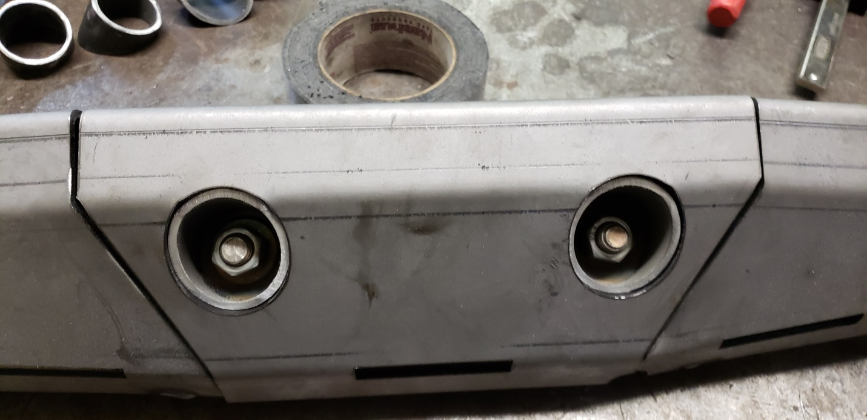

Step 10: Now you can remove the side plates are test fitting and weld the outside of the shock bolt tubes to seal them to the inner plates.
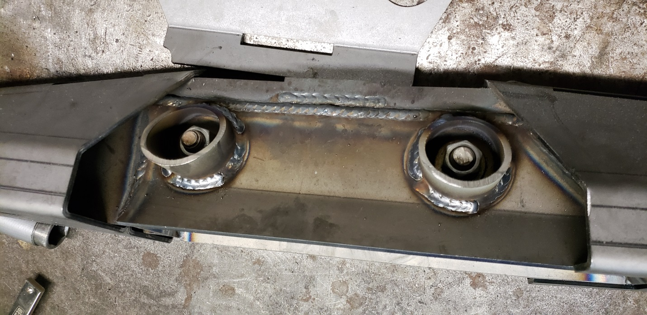
Step 11: Fit the side plates onto the links and tack them in place. You will have up to an 1/8” gap between this plate and the front or back plates. This allows for good penetration of the plates since you will be grinding them flush at a later step.
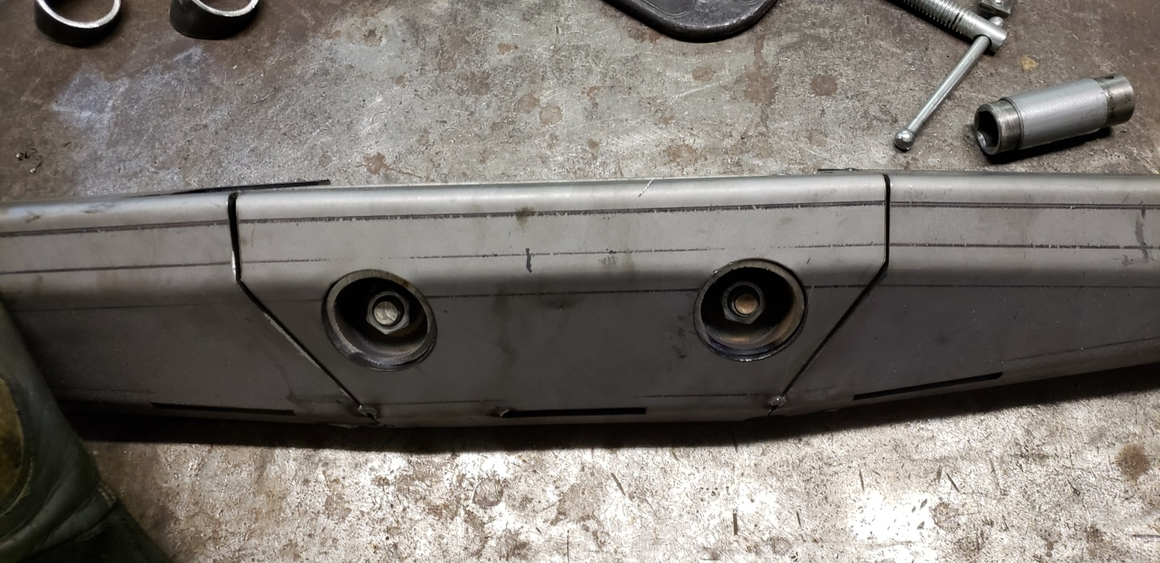
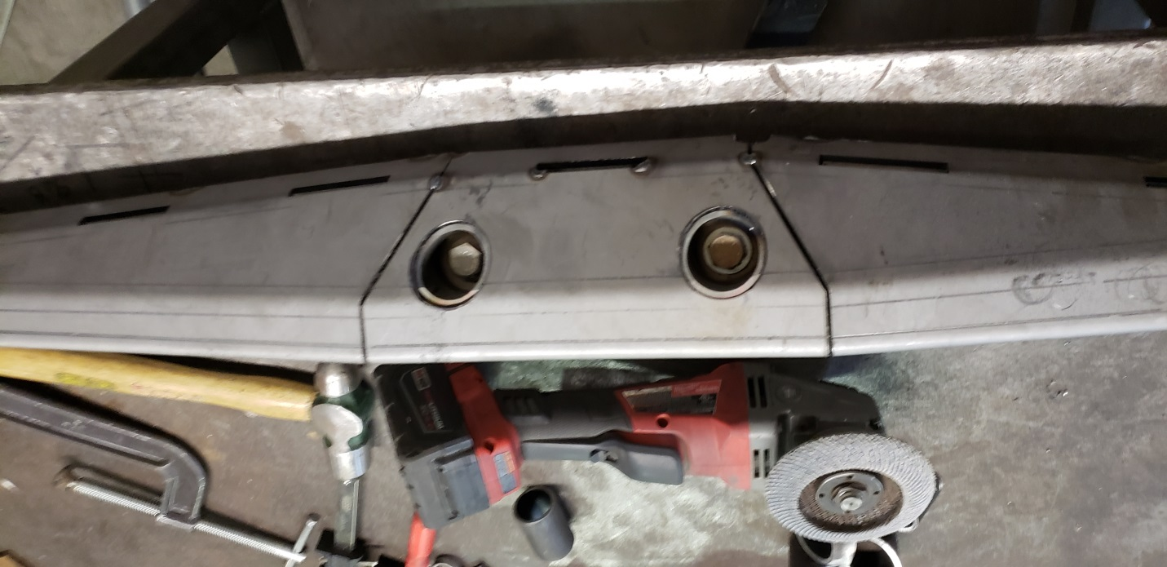
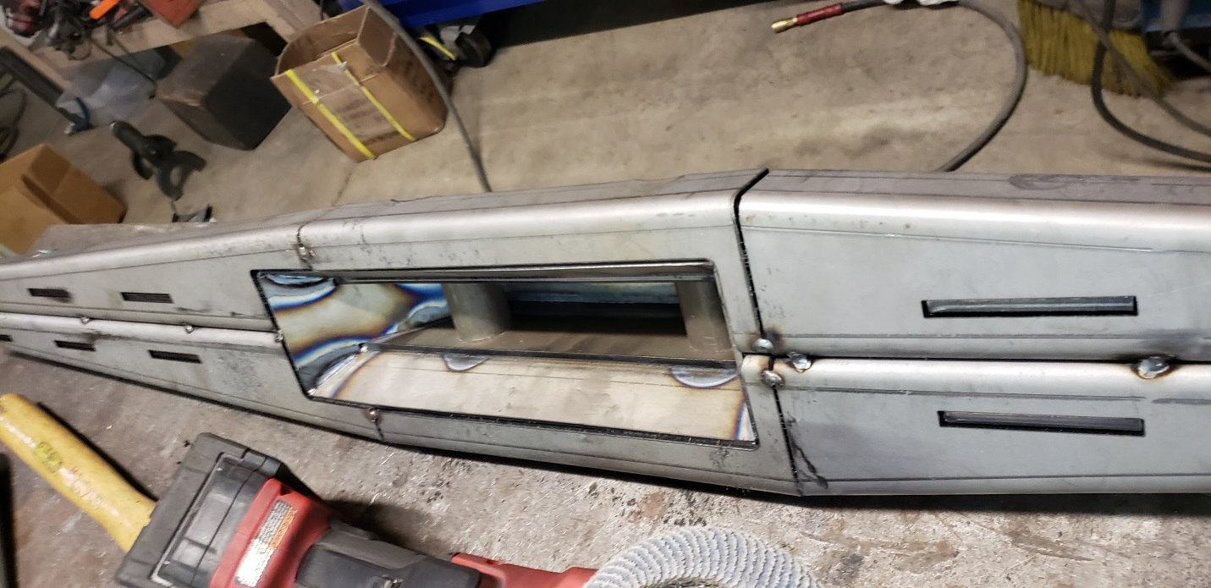
Step 12: Now that all the side plates are fit and tacked in place. Start welding them together. I start welding up the tab n slot holes alternating top and bottom front and back to prevent warping. The Tab and Slot holes on the bottom I usually do a 2 or 3 pass on them. One weld tieing in the tab to the plate on both sides, then a cover pass over it all. I then weld the seams on the top and sides. Then weld the center weld on top and bottom. Weld the shock pocket but you don’t need to weld down in the shock pocket as it is sealed from the outside already. 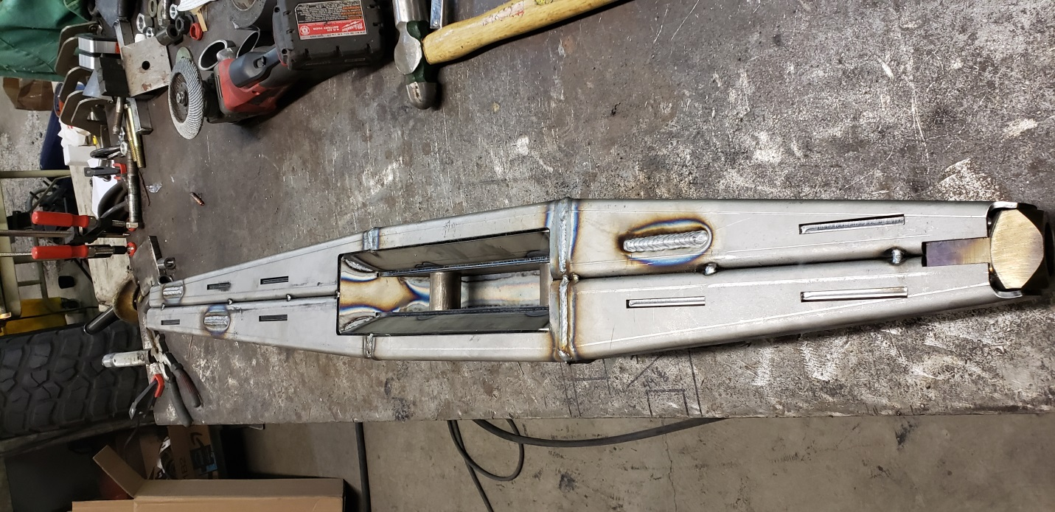
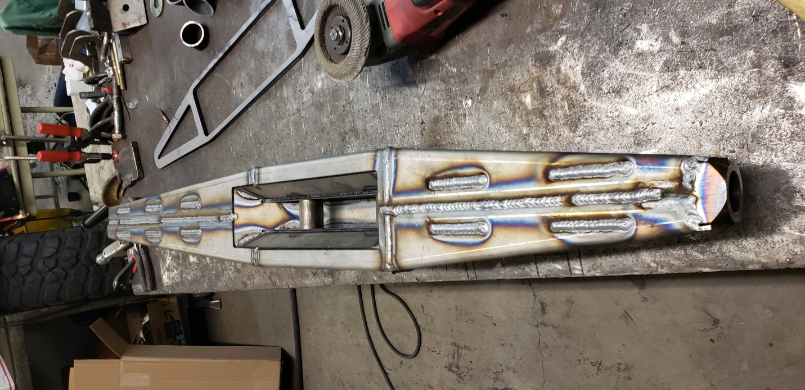
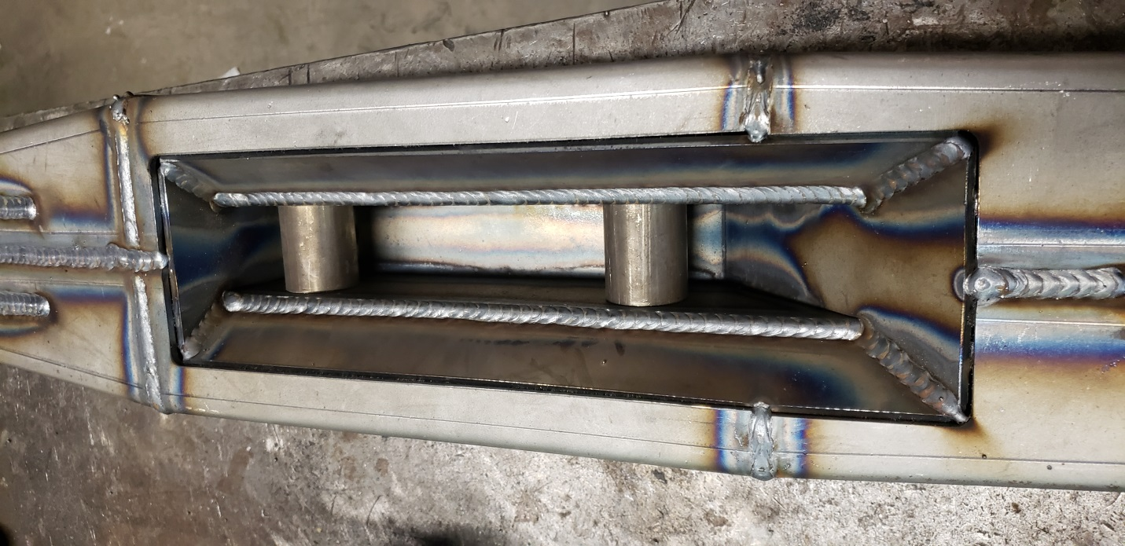
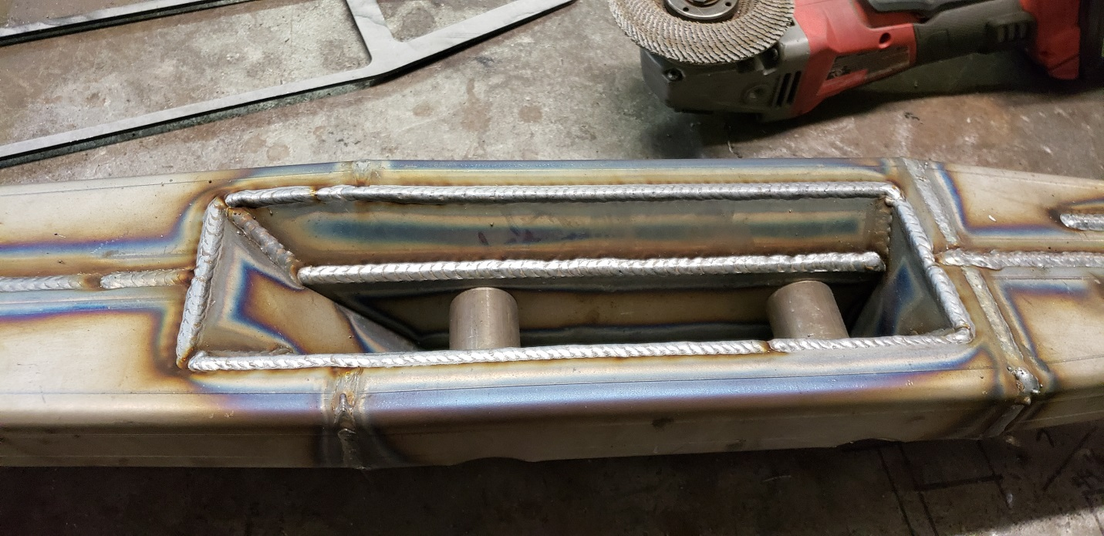
Step 13: Grinding time. Use a flap disc to finish the welds smooth for bash plates and overlays to fit flush. Grind both seams on side plates flush. Grind the middle plate to front and rear plates seam on top flush. Grind the bottom rib where the bash plates sit flush with sides and rounded till bash plates fit. Grind welds on top of link near bung flush for bung grabber to sit flush. Grind tab n slot welds on the top closest to shock pockets flush.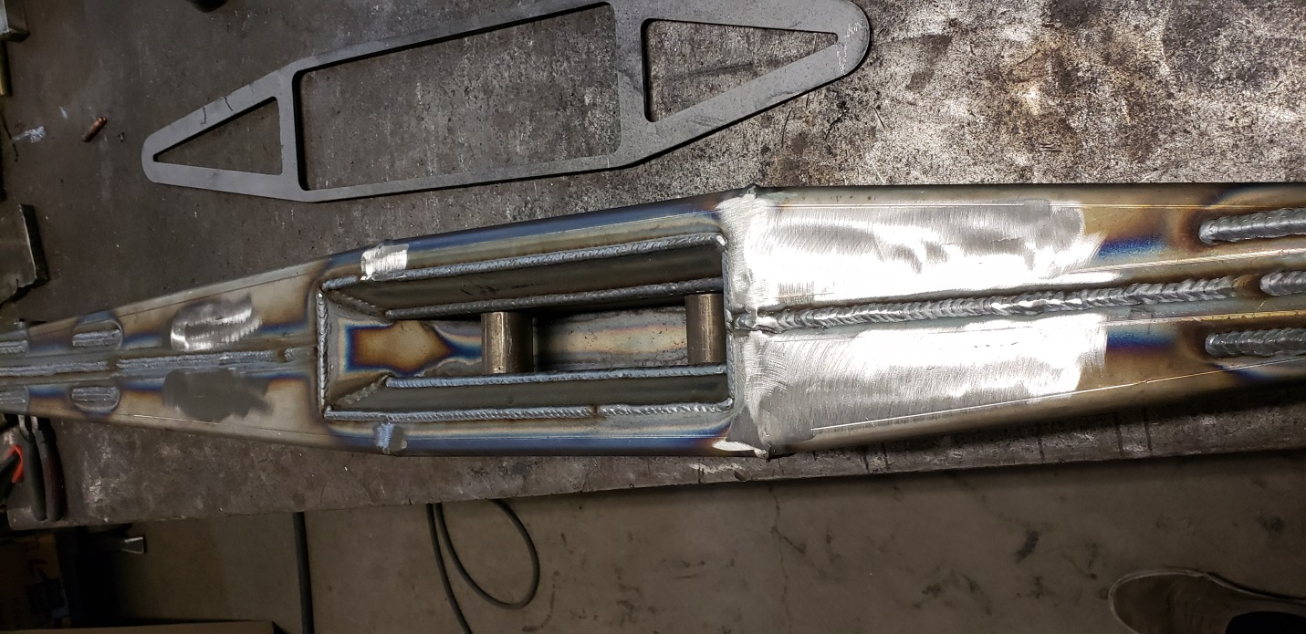
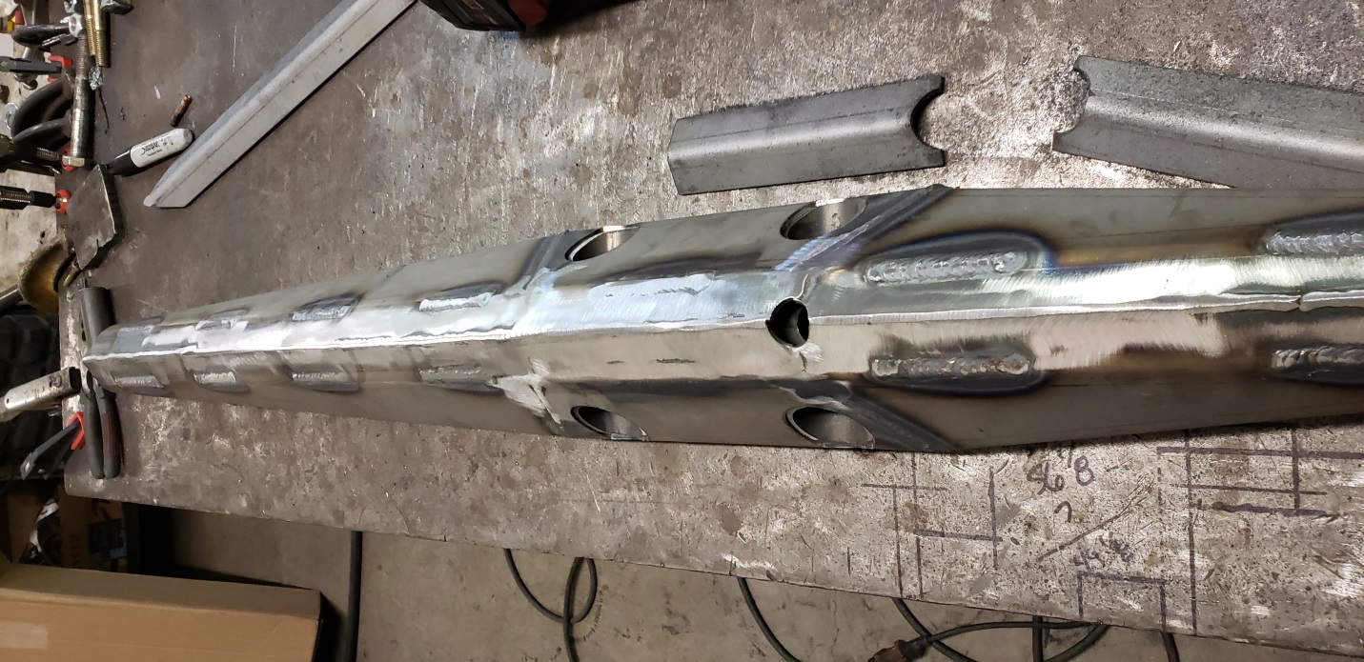
Step 14: Fit the shock pocket drain tube you cut earlier. Tack it so it sits slightly inset from flush on the INSIDE of the shock pocket. Tack it in place and I grind the outside to match the bottom of the links. Weld the tube in place Inside shock pocket and outside.
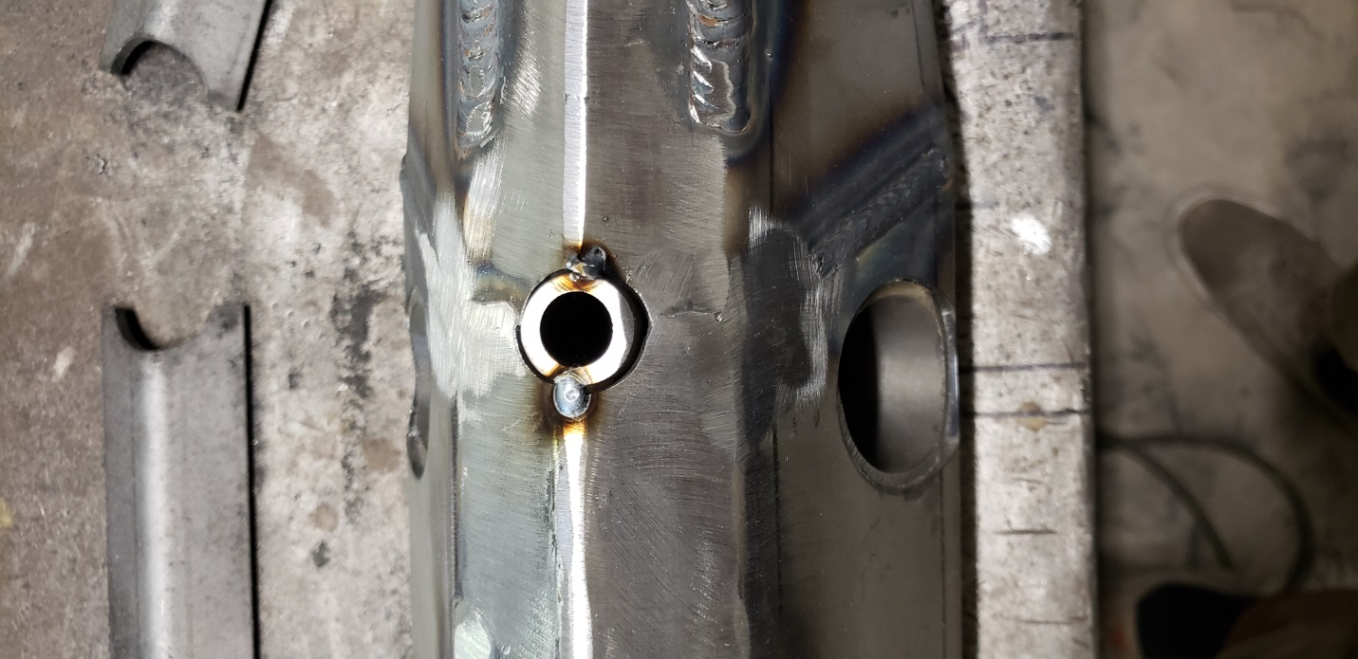

Step 15: Now fit the bottom bash guards. Fit them so there is approx. 3/16” Gap between them so you can get a full penetration weld to the trailing arm below.
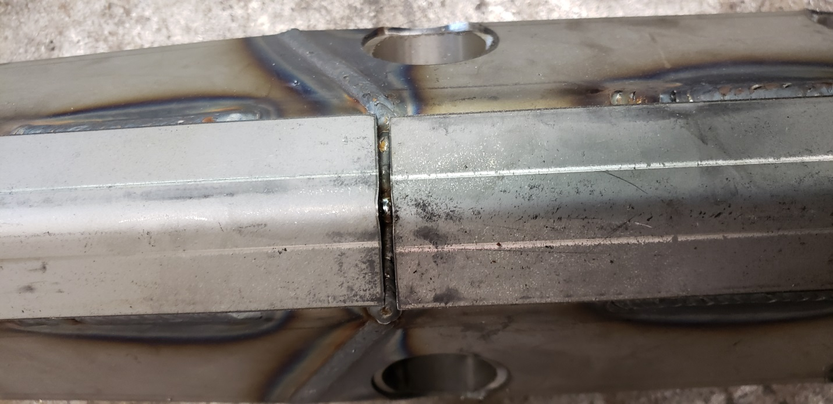
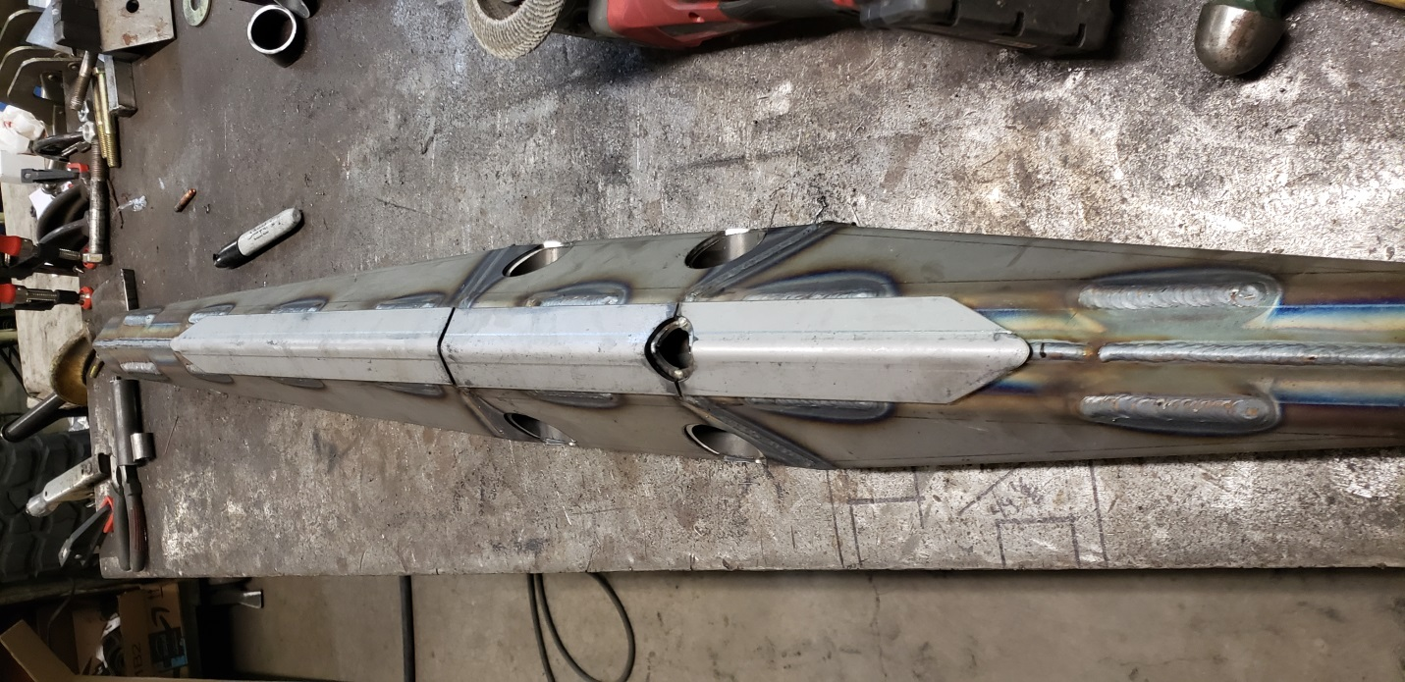
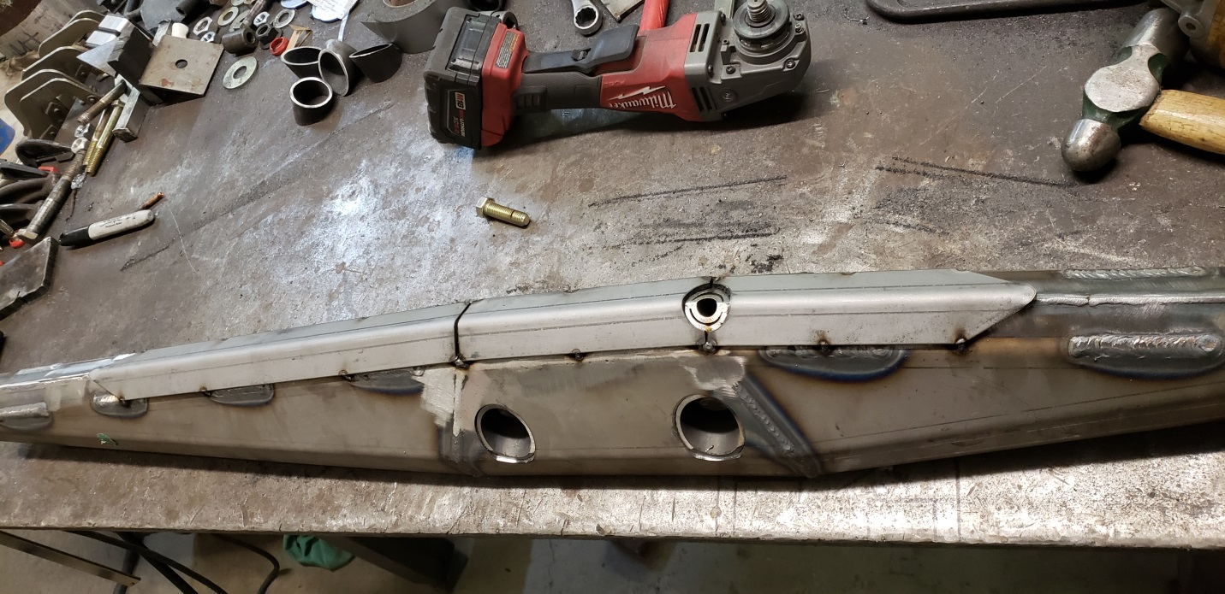
Step 16: Weld the bash plates in place. I grind the bottom seams flush for a more aesthetically pleasing look.
Step 17: Fit the Side and Top overlay plates. Use a good amount of tack welds to hold them in place. If you don’t the thin strips will warp when welding and cause issues. Clamp where necessary to get a tight flush fit. Grind any welds that intrude from allowing the plates to sit flush. Tack the diamond shaped bung grabber on top of the rear bung with point if diamond going forward, as seen on photo below.
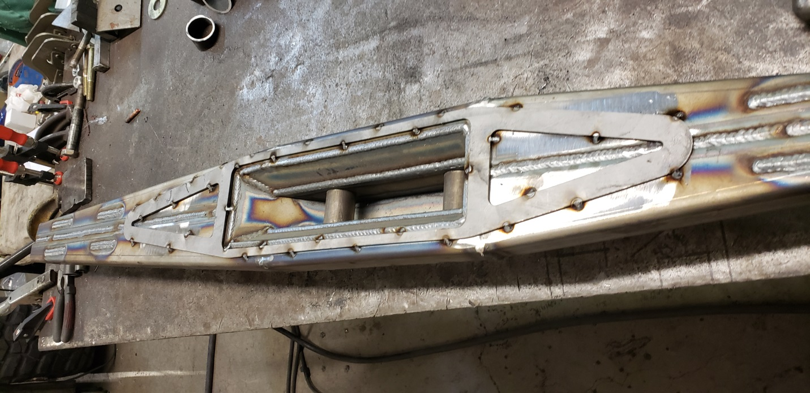
Step 18: Now dial in the welder for the thinner overlay plates and stack some dimes. This is what everyone will be looking at.
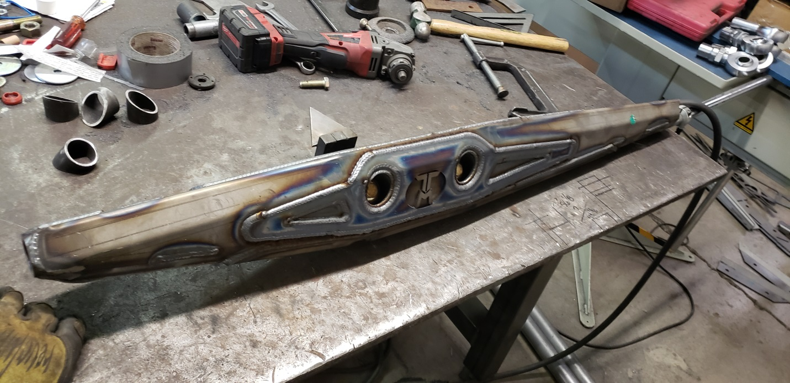
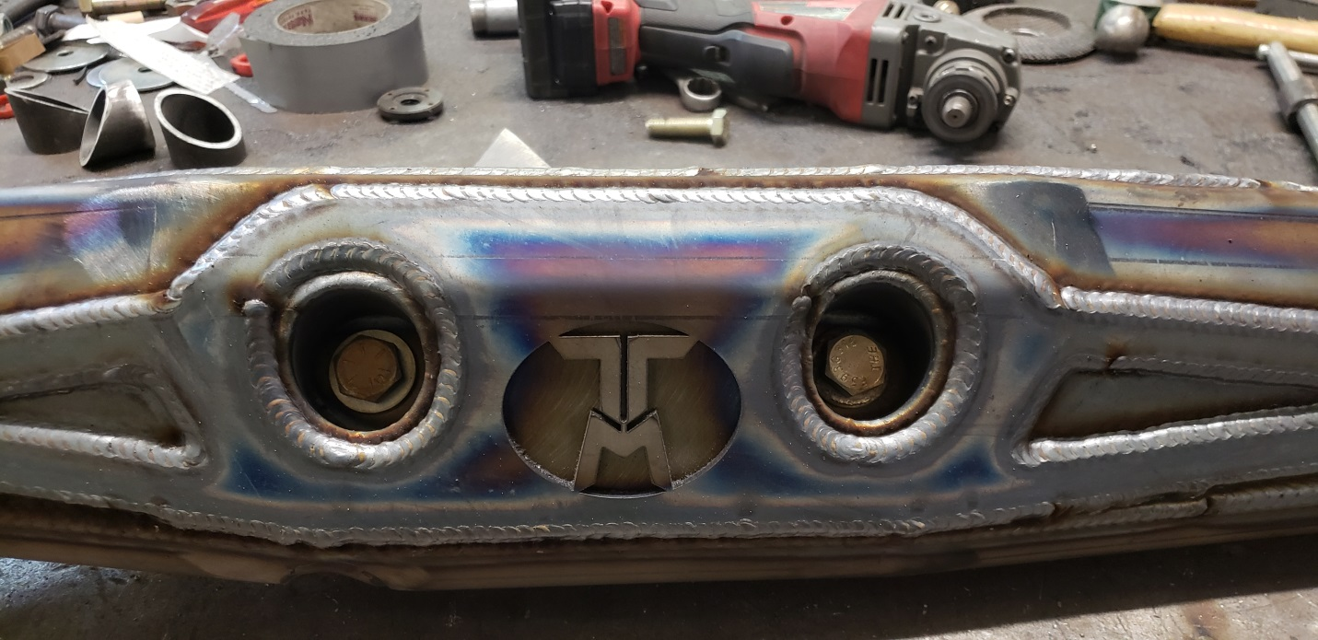
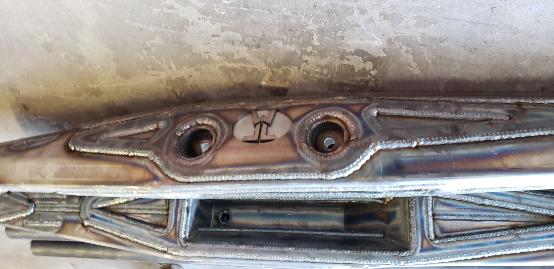
Step 19: Fit the bushing or front uniball to the correct angle, grinding as needed. Weld it fully and use supplied wrap for a indestructible trailing arm. Uniballs will require more grinding and I cut the wrap provided in half since it is designed for a 2” tube not the larger uniball cups. Or make yourself a new uniball wrap out of some strap plate.
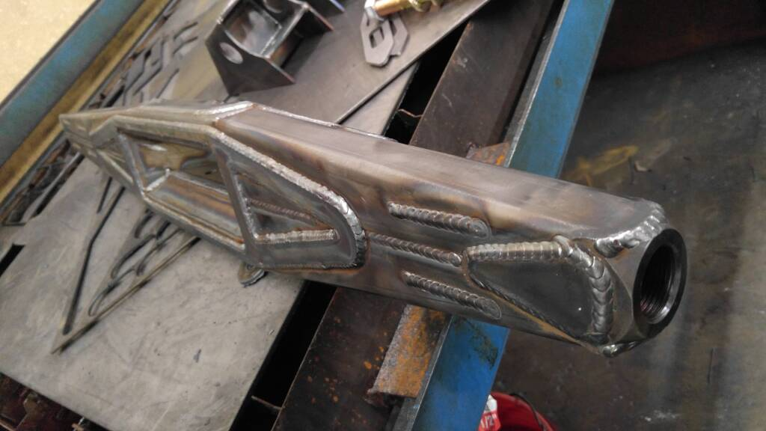
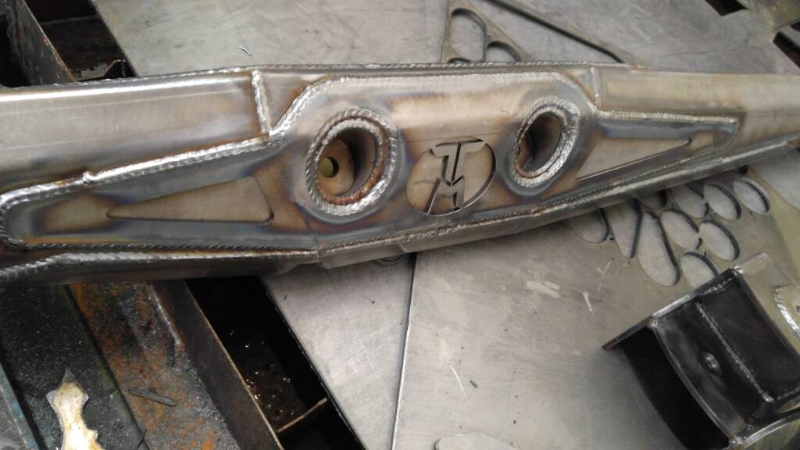

55 Inch Trailing arm CUT instructions

Below are instructions on how to cut the 60 inch trailing arm kits to make them 55inch long. Using the new provided rear outer plates and modifying existing plates as detailed below.
Step 1: Print out the Front Plate cut Template. I open with MS Paint. Print setting and make sure scale is 100%. The straight end length should be 1inch. As you will be cutting 1” off the front of the links and 4 Inches off the rear to get proper shock placement. Cut template out and use sharpie to trace it onto the front outer plates. The wrap does not fit if you try and wrap around the entire piece. Fit the bushing notch part first, then the top and inside lip. Repeat for the other 3 front outer pieces. I cut them with a cutoff wheel and flap disc them to shape.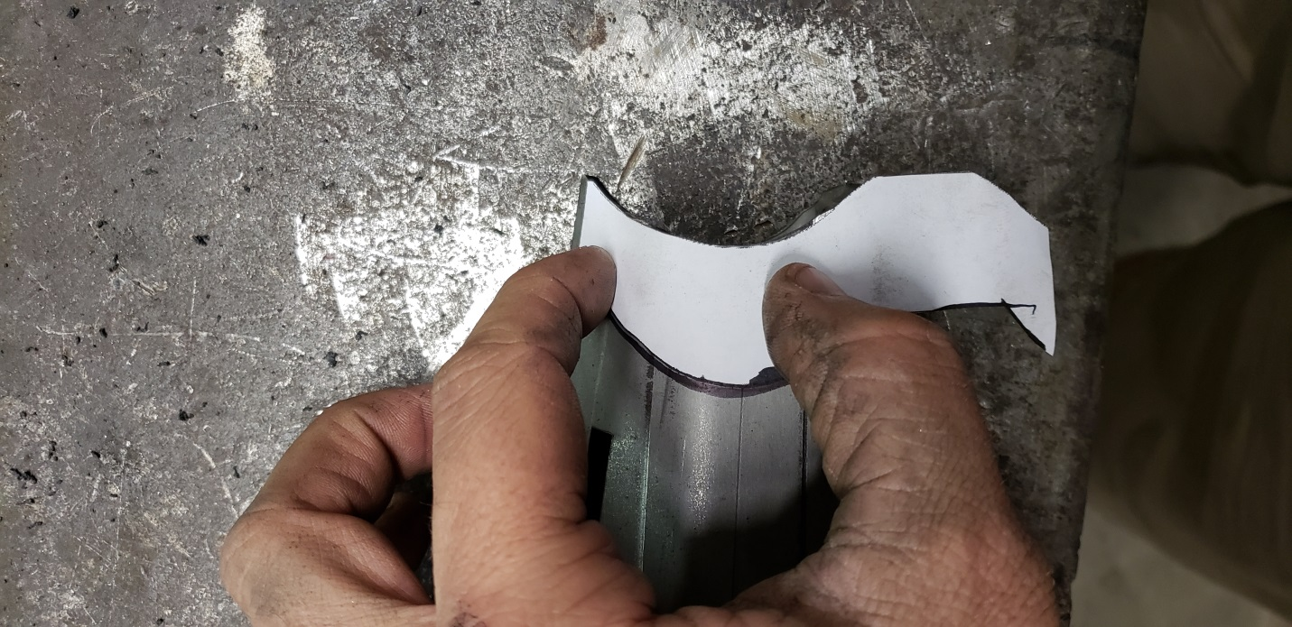
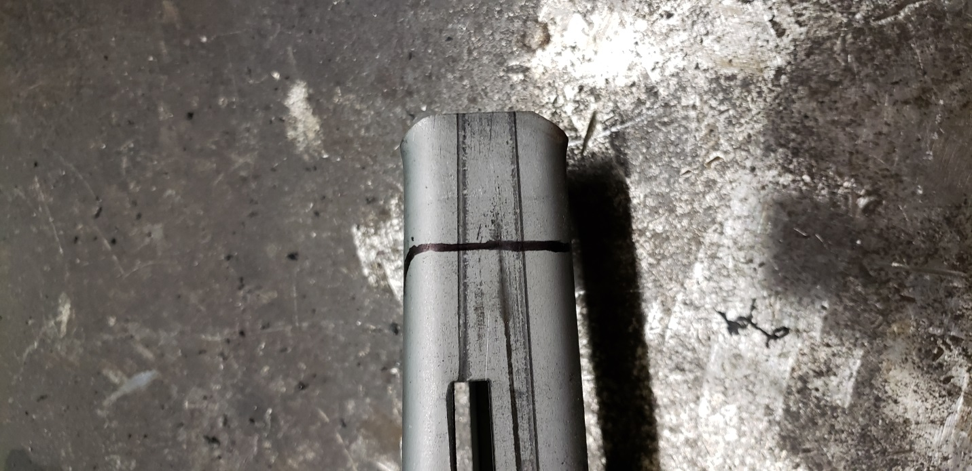
Step 2: Grab your 2 main ribs. Measure from bung end back 4 inches. Put a mark.
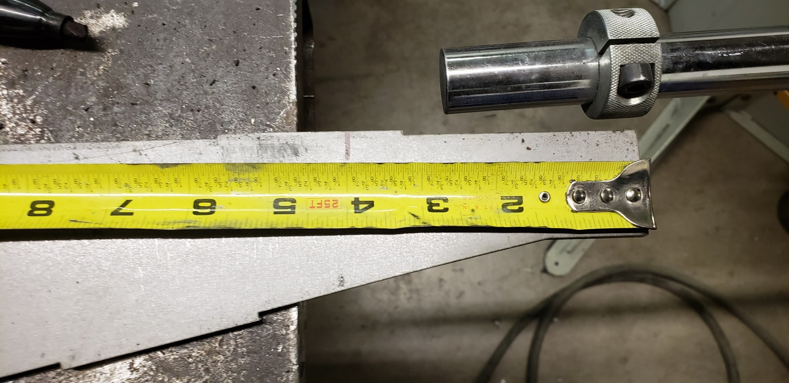

Step 3: Using the uncut main rib line up the end with that mark and the top flush with the top of marked main rib.
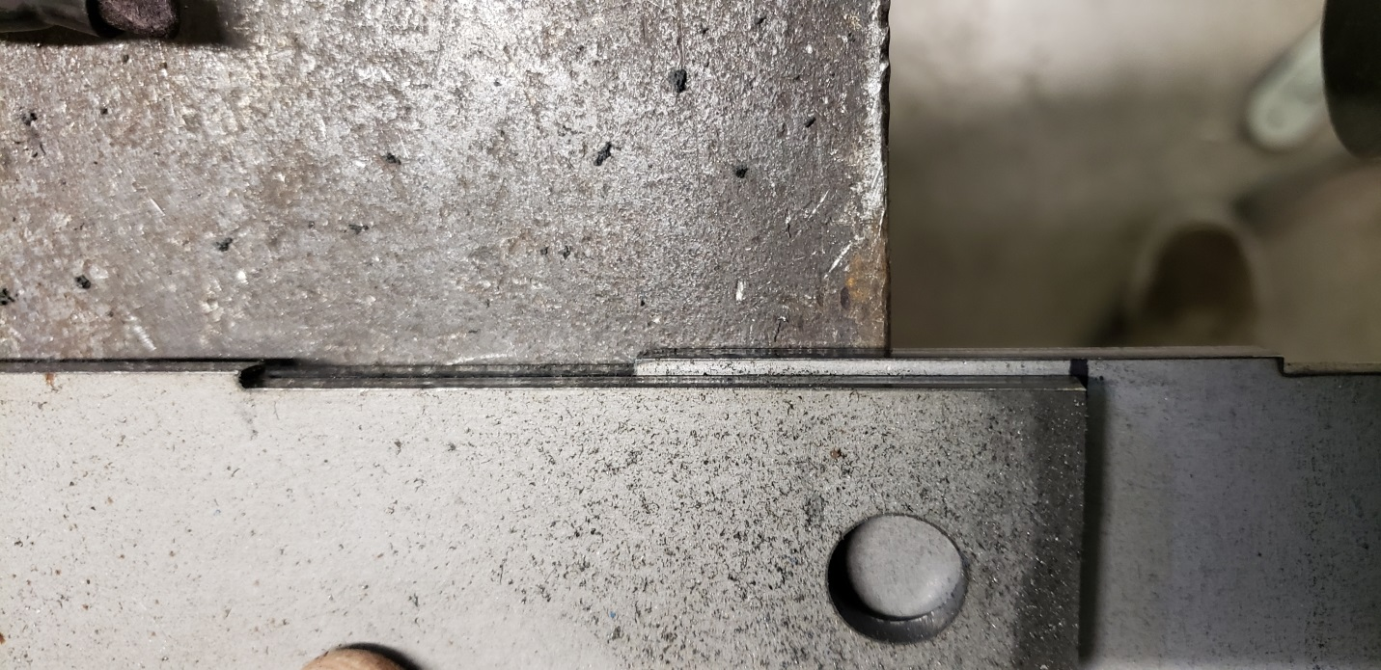
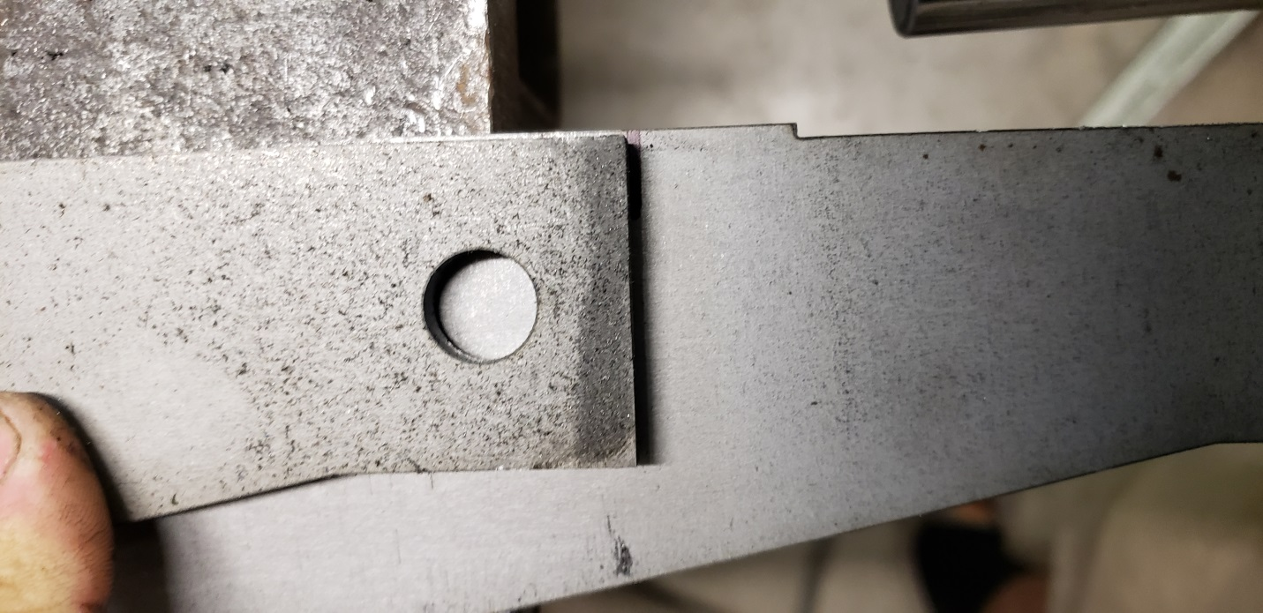
Step 4: Trace the main rib along the end and straight bottom edge, BUT not the entire piece, along with mark for new plug weld hole.
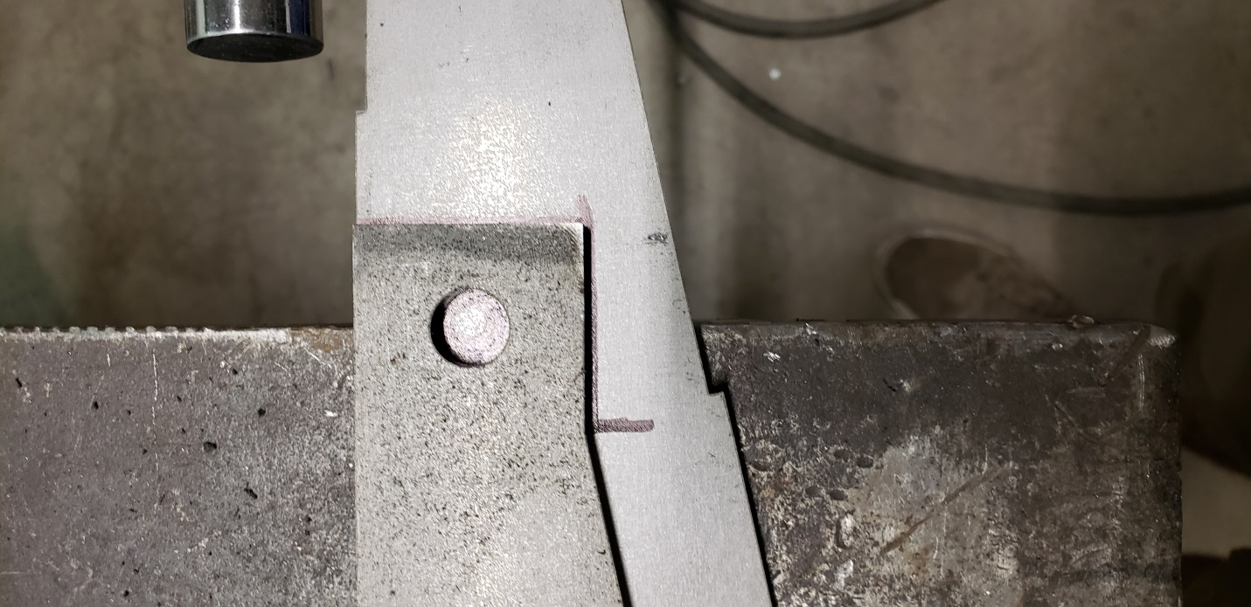
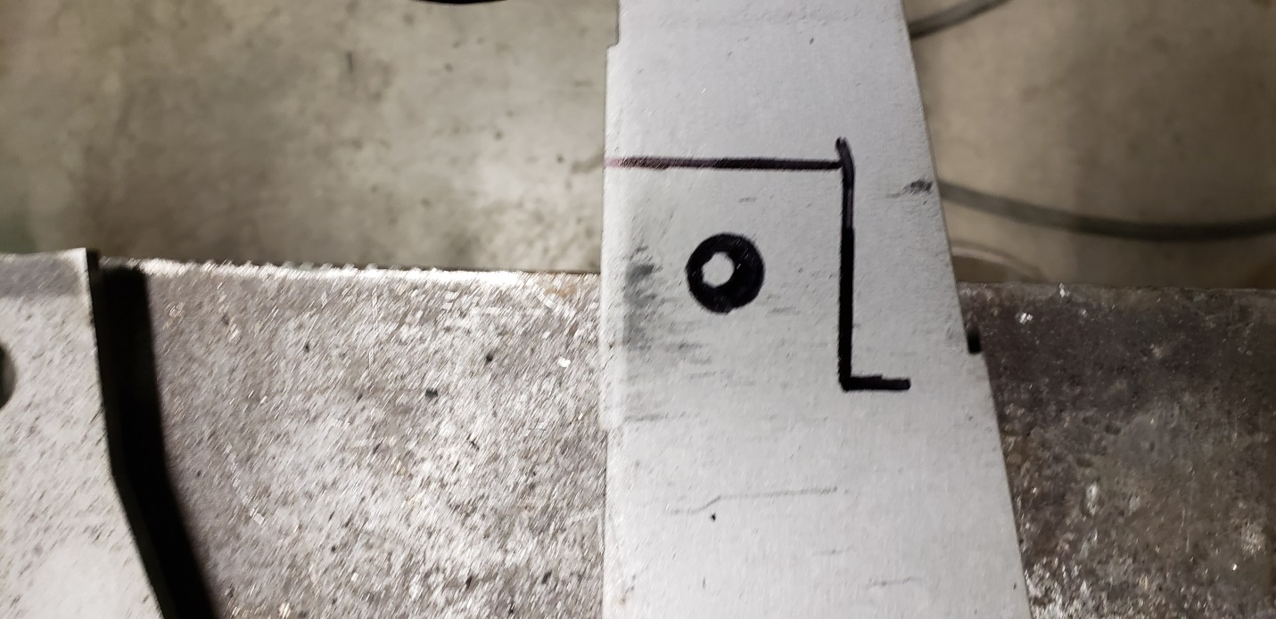
Step 5: Now using a straight edge draw a straight line from the corner you see above down to the point on the main rib below shock bolts.
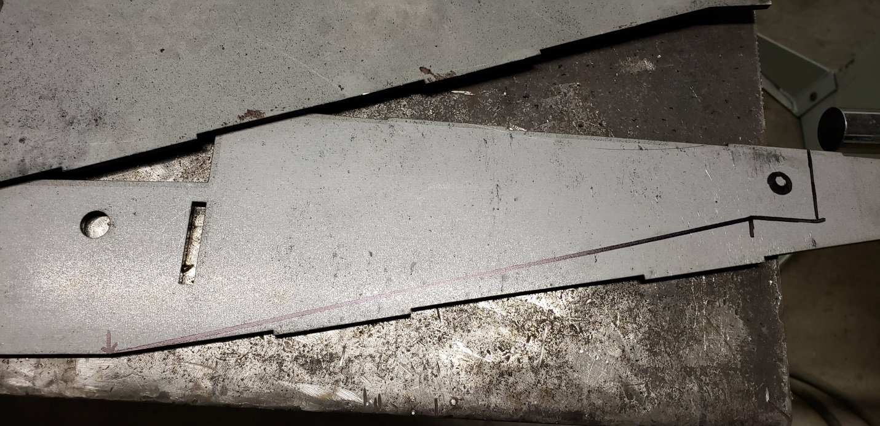
Step 6: You can now drill the ½” plug weld hole. And cutoff wheel the main rib to the shape you see drawn above. Once cut out, deburr, and use as a template for the other 3 main ribs.
Step 7: Grab the Rear Bottom Bash plate. It should measure approx. 13 3/8” from end to end. You will now cut it down to 12 ¾” long leaving the pointed end unchanged. Measure back, and mark a straight line. Cut it down and it’s ready to go. Repeat for other link.
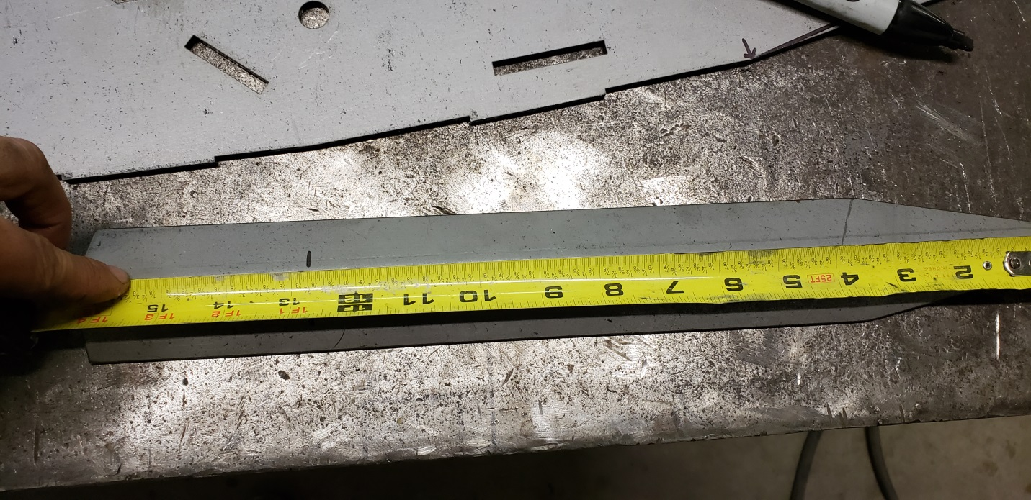
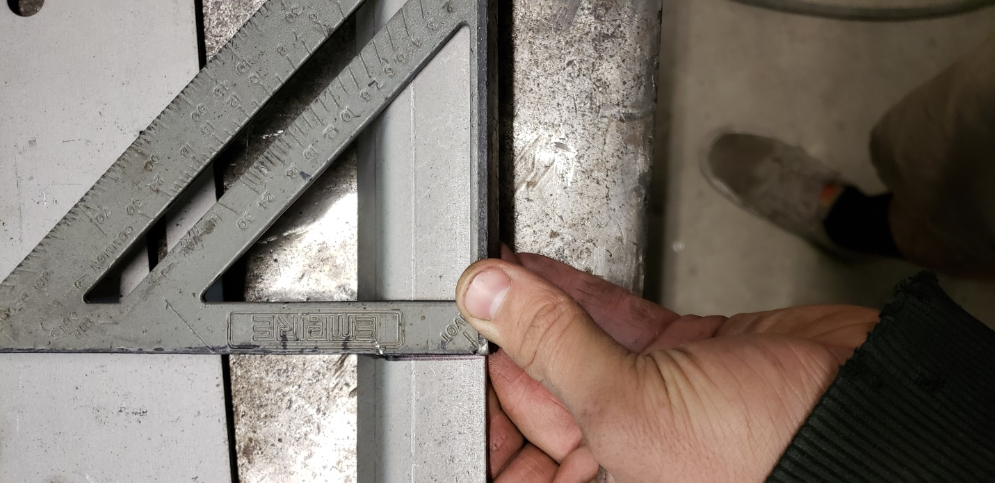

You have now modified all the pieces from the 60inch trailing arm kit to make them a 55inch trailing arm. Use the modified pieces Along with supplied shorter rear side pieces and follow the standard assembly instructions.

60 and 55 Inch Trailing Arm Shock Bolt Tube 1 ¾” x .120 DOM Tube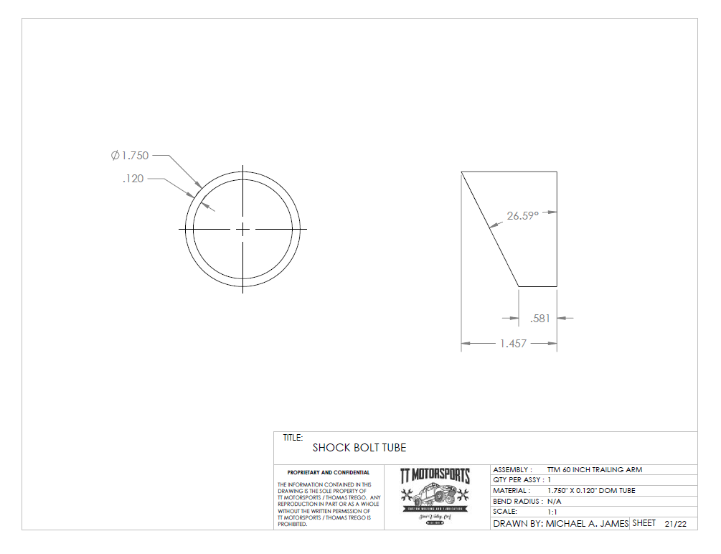
60 and 55 Inch Trailing Arm Shock Pocket Drain Tube. ¾” OD Tube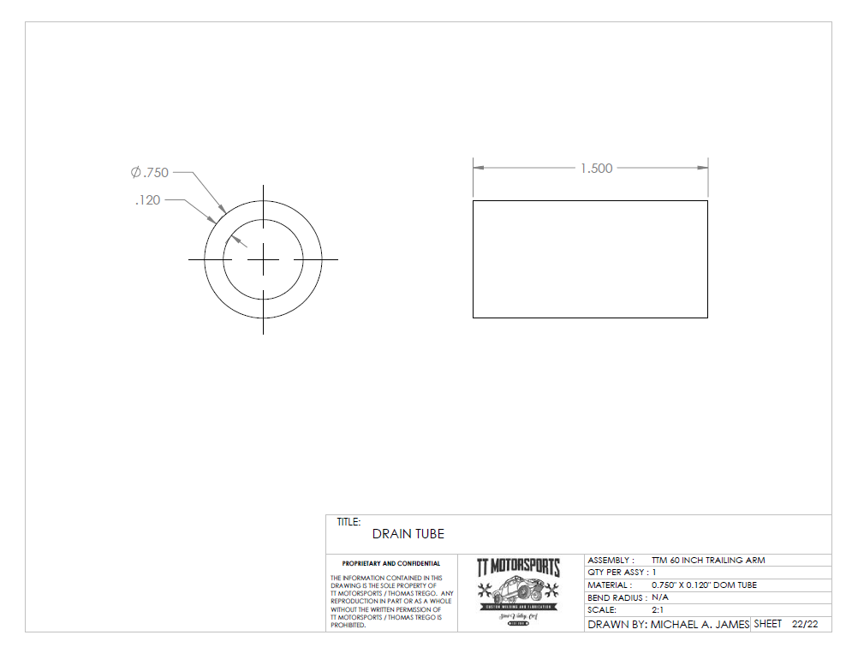

49 Inch Trailing Arm Shock Bolt Tube 1 ¾” x .120 DOM . I grind the flat face on it once tacked to trailing arms.
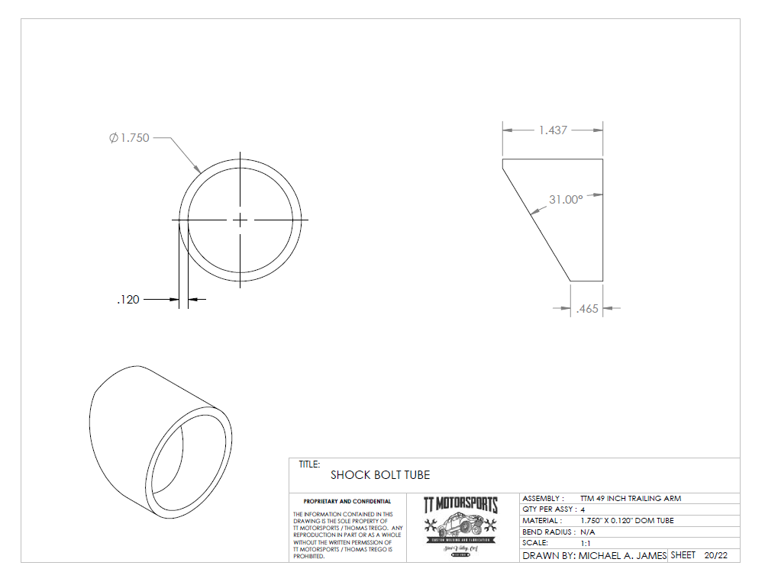

49 Inch Shock Pocket Drain Tube. ¾” OD Tube I grind the bevel onto it once tacked to Trailing arms.
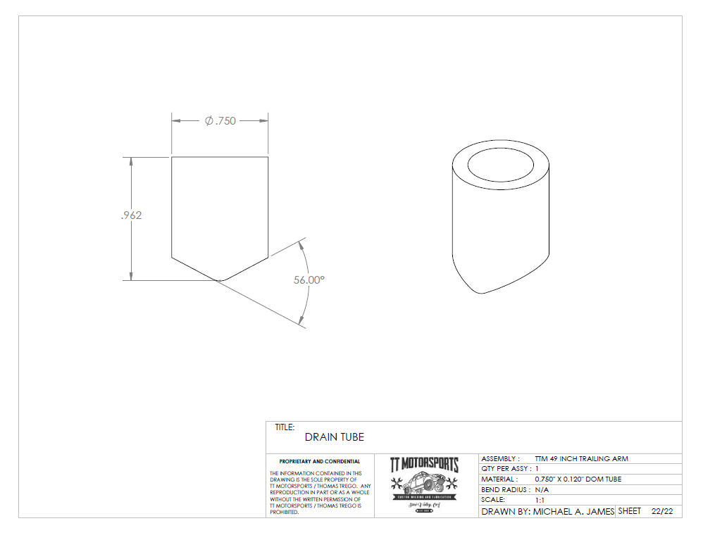

55Inch Link Front Plate cut Template

